Ivan Flores

Alix Naugler

Hanna Willwerth

ACE 592SAE

Dr. Jared Hutchins

Bigfoot, Bigger Data: The Tale of Crunk Cryptids

# Introduction

Bigfoot—also known as Sasquatch from the First Nation Halkomelem word *Sasq’ets* meaning “hairy, wild man”—originated from Native American tribes in the Pacific Northwest in the U.S. and British Columbia in Canada (Native American Legends, n.d.). In general, Bigfoot is an important figure in Native American and First Nation folklore, legends, and tradition; specifically, both oral and pictorial transmission have conveyed this primate as a supernatural creature, a caretaker of the land, and an auspicious symbol that can transcend the physical and spiritual realms (Sinclair, 2017). The term “Sasquatch” was preliminarily coined by J.W. Burns, a teacher on the Chehalis Indian Reservation in British Columbia, in an article he wrote for the magazine *Maclean’s* in 1929 where he compiled testimony from those who claimed to have seen this creature inhabiting the area (Sasquatch, n.d.). Interestingly, the first documented sighting of Bigfoot dates to an 1884 article in the *British Colonist* which described a “half man, half beast” near Yale, British Columbia. Since then, the legend of Bigfoot has taken hold in the American and Canadian imagination—from loggers working in the wilderness to truckers driving through mountainous terrain.

Existing empirical literature on the mythology of Bigfoot has predominantly concentrated on confirming or rejecting its existence (see Dennett (1989), Meldrum (2004), and Meldrum (2007) for details). Given this, there is a paucity of economics-related research on the subject. In one study, researchers tested DNA from “Bigfoot” hair samples submitted from museums and personal collections (Sykes et al., 2014). Results indicated that all hair samples could be traced back to extant animals, such as bears, dogs, deer, and boars. Another study on this topic integrated geo-referenced Bigfoot sightings and ecological niche models and found the purported geographic distribution of Bigfoot sightings closely mapped that of the American black bear (Lozier et al., 2009). This previous research posits a lack of hard evidence regarding the existence of Bigfoot, implying that in most if not all reported sightings Bigfoot was “bearly” there.

This economics-based research project will build upon existing research by exploring the determinants of Bigfoot observations themselves. Specifically, this project integrates geo-coded, U.S.-based reports of Bigfoot sightings from 2002 to 2012—gathered by the Bigfoot Field Researchers Organization (BFRO)—with detailed, county-level data on alcohol overconsumption in the U.S. population—from the Global Health Data Exchange—to help unearth the mystery surrounding Bigfoot. [1] The primary research question of this analysis was to what extent do binge drinking rates impact the total number of reported Bigfoot sightings in the U.S.[2] The hypothesis was that U.S. counties with higher rates of binge drinking among residents would have *more* reported Bigfoot sightings. This is corroborated by research that suggests alcohol abuse and consistent binge drinking—likely leading to alcohol-induced psychosis—can foment delusions, hallucinations, and other forms of bodily impairment which can cause individuals to hear and see things that are not really there (see Ackermann (2022), Cohen & Johnson (1988), Fan et al. (2012), and Maurage et al. (2012) for details). Additionally, it has been documented that short-term yet heavy alcohol consumption can specifically damage one’s vision via these symptoms: blurred or double vision, weakening eye muscle coordination which can slow one’s reflexes, decreased sensitivity to contrasting colors, and tunnel vision due to slower pupil dilation (Mile, 2021). Thus, given that alcohol consumption—specifically binge drinking—can induce distorted perceptions of reality and greatly impair normal bodily functions related to eyesight, reported Bigfoot sightings may be higher in localities where binge drinking is more common in the general population. This analysis seeks to assess this hypothesis.

# Analyses

The following analyses were used to contextualize and answer the posed research question. This section starts by conducting exploratory analyses of both the BFRO and Global Health Data Exchange datasets, separately, for the period of study (i.e., 2002 to 2012). Then this section concludes with analyzing both the geospatial and statistical relationship between binge drinking rates and Bigfoot sightings in the U.S.

## Descriptive Analyses

The initial exploratory analysis focused on identifying key trends in the data, including those of potential explanatory variables such as visibility, moon phase, precipitation, time, and geography associated with the Bigfoot observations as well as time and geographic trends for U.S. county-level binge drinking rates.

According to the histogram results shown in Figure 1, poor visibility did not appear to be associated with Bigfoot sightings in the U.S. from 2002 to 2012. These findings actually suggest the majority of sightings occurred on days with high levels of visibility (i.e., 8 miles or greater as denoted in the last column of Figure 1). Additionally, of the 1,624 Bigfoot sightings represented in the data, reports of rain, snow, and no rain were found in 588, 72, and 964 of them, respectively. Therefore, despite variation in these self-reported climate characteristics, visibility across all Bigfoot sightings was relatively high, positing adverse weather conditions—that could reduce visibility—did not decrease the probability of observing Bigfoot.

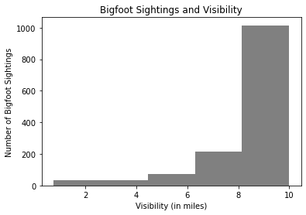

Figure 1

Similarly, a specific moon phase did not appear to be a prominent factor in reported Bigfoot sightings. As shown in the histogram in Figure 2, Bigfoot sightings were relatively evenly distributed across moon phases as there were only slight spikes in sightings during the full moon phase. Given the supernatural beliefs and traits that are associated with Bigfoot, one could surmise that there would be an uptick in observations during a full moon given its cultural folklore. Yet, that does not seem to be the case here.

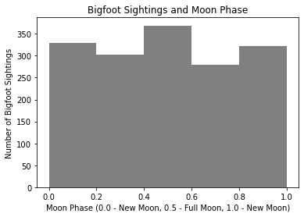

Figure 2

When examining the number of Bigfoot sightings over time—as depicted in Figure 3—they seemed to peak in 2004 before dropping steadily until 2010, when sightings then started to rebound after. Some proposed explanations of this downward trend include the proliferation of the Internet and social media which has increased the ease of sharing experiences related to Bigfoot sightings to a larger audience but also opened up the door for greater scrutiny by the public at large, perhaps deterring interest; also, some have stated that the decline could be attributed to individuals no longer being interested in going into the woods as frequently as before which would abate the likelihood of a sighting (Neuharth, 2020).

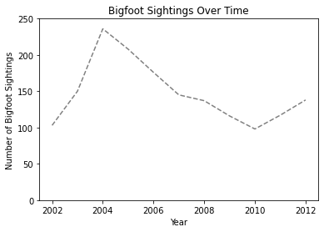

Figure 3

Concerning the geographic distribution of Bigfoot sightings, the data suggests they have been clustered among a few U.S. states as shown in Figure 4. Specifically, the analysis indicated that the top five states with the most Bigfoot sightings from 2002 to 2012 were Washington, Florida, Texas, California, and Illinois. These five states and the top ten states—both shown in Figure 4—constitute almost 40 and 60 percent, respectively, of the U.S. sightings during this period. Interestingly, Bigfoot sights have not been all concentrated in the Pacific Northwest and seem to be representative of disparate U.S. regions (i.e., the Southeast, Southwest, Midwest, and West). Of note, Maine, Hawaii, and Alaska had no reported Bigfoot sightings during this period thus these three states were not included in subsequent analyses.

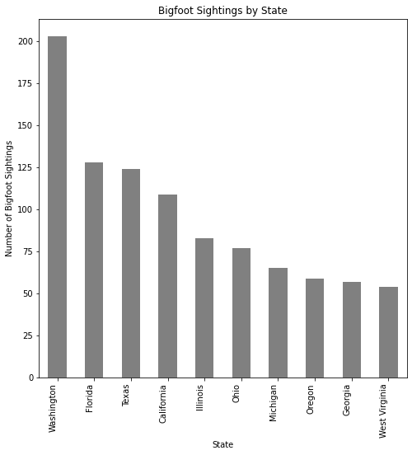

Figure 4

It is important to note that the states that had the highest total number of Bigfoot sightings over this ten-year period did not overlap with those that had the highest average county-level binge drinking rates during the same period. As shown in Figure 5, the top five states for the latter metric were North Dakota, Nevada, Wisconsin, South Dakota, and Iowa. These states had total Bigfoot sightings of only 3, 2, 31, 5, and 11, respectively. For additional context, the average county-level binge drinking rate at the state-level ranged from a high of 42 percent in North Dakota to a low of 26 percent in Vermont—a range of 16 percentage points. Conversely, the range of total Bigfoot sightings at the state-level varied more, with a high of 203 sightings in Washington to a low of zero sightings for Hawaii, Alaska, and Maine.

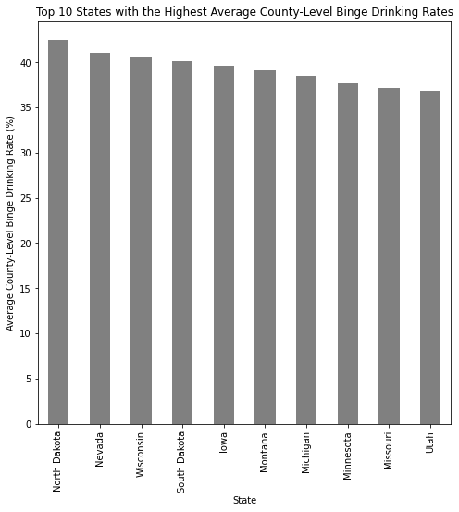

Figure 5

With regards to exploring these data in tandem over time, Figure 6 depicts the average county-level binge drinking rate—at the national-level—against the total number of Bigfoot sightings in the U.S. from 2002 to 2012. Of note, the average rate of binge drinking at the county-level appeared to be relatively consistent across time, ranging from 31 percent to 35 percent of a county’s population when looking at both genders combined. This trend holds even when parsed out by gender. Figure 6 also posits that the binge drinking rates at these geographic levels greatly differ by gender in which across this period and for all counties the annual rates were on average 24 and 40 percent for females and males, respectively. Thus, while county-level binge drinking rates did not seem to vary nationally, the number of Bigfoot sightings at first increased and then gradually abated with a slight uptick in later years.

Figure 6

## Text Analyses

In addition to being geo-coded, the Bigfoot sightings data provided by BFRO also included substantial amounts of text. Specifically, reporters of Bigfoot sightings often submitted a considerable amount of detail about their experiences where they claimed to have seen Bigfoot. This research project used this type of data as an opportunity to conduct several text and sentiment analyses, helping to provide additional context and reveal further trends behind the potential determinants of Bigfoot observations.

After removing stop words, the most common words in the data that were submitted by reporters were primarily action words such as “heard,” “saw,” and “looked.”[3] Aside from these, other words that had a high frequency of use included “road,” “woods,” “night,” “sound,” “feet,” and “large.” Figure 7 visualizes these frequencies in a word cloud, depicting the most common words as those with larger font sizes.

Figure 7

The most common words did not change significantly across the five states with the most Bigfoot sightings, although notable exceptions included the following: “creature” being used in Florida sightings; “animal” being used in Texas sightings; “bigfoot,” “lake,” and “bear” being used in California sightings; and “house” and “deer” being used in Illinois sightings. These results strengthen the supposition that Bigfoot sightings were more likely cases of mistaken identity with other fauna—such as bears and deer.

To conduct a sentiment analysis of all 1,624 Bigfoot observations during the 2002 to 2012 period, a rule-based analysis tool called the Valence Aware Dictionary and Sentiment Reasoner (VADER) was utilized.[4] Findings from this analysis suggest that Bigfoot sightings tend to be a somewhat positive experience for reporters given the median sentiment score across reported Bigfoot sightings was 0.2050 (where 1 and -1 represent the extreme values of the most positive and negative sentiment, respectively). However, there were some negative outliers that reduced the mean sentiment score to 0.1145, comparatively.

The following two groups of quoted texts represent the most negative and most positive Bigfoot sighting reports, respectively, found in the BRFO data. These paragraph descriptions of reported encounters with Bigfoot had sentiment scores of -0.9985 and 0.9994, respectively:

*“This is a compilation of experiences over a period of years in the same area (1988- 2009) - feeling of being watched, wildlife silenced, tree breaks, strong smell once, numerous late night vocalizations, rock knocking, things being thrown near our tent and an actual daytime sighting … Birdsong of various types is always present, but as we made our way toward the tree line, the birdsong and even insect noise seemed to cease. I looked up, no indication of foul weather or damp wind, indicating rain. Our group ( I think 7 or 8 of us) was familiar with the deep woods and a couple people noted that this was strange. For some reason, we all stopped in our tracks, even though no one had heard anything; everyone was looking around at each other and listening. Something seemed wrong … We got out of our vehicle to begin setting up camp as we had done several other times in this area and noticed an almost vomit-inducing stench. It was not the smell of something dead, it was like a combination of sun-baked garbage and feces …. But then later in 2003, another type of sound in this area made my blood turn to ice water … I came to a sickeningly horrifying conclusion that in all the years of voice I'd studied and heard, not one human had ever uttered something at this tone, nor could they do it at this volume …. I was too frightened with the realization that what I had just heard was impossible- impossible! No creature existed that could make that sound-- unless-- no way-- NO WAY! Then I remembered that this area had quite a few sightings of Bigfoot over the years … The ranger looked at me like I was under the influence ... Then I felt faint, like I was going blind & seeing colors and shot up with some halucinogen all at once- I watched as a HUGE, hair-covered, dark cinnamon-colored human-like thing cleared the ditch in one stride, glided into the tree line in one more lightning step and then stood absolutely still. …. Fear and curiosity-yikes.”*

As demonstrated by the above account, Bigfoot sightings can be a very fear-inducing and traumatic experience for some individuals, accompanied by “vomit-inducing stenches,” unnatural absences of noises, and a malicious and creepy atmosphere. For others, as demonstrated below, the experience, while shocking in the moment, can spark a lifelong interest in and devotion to the hunt for Bigfoot.

*“My encounter happened in early June of 2010. I took a friend to the Marienville/Timberline ATV trails northeast of Marienville, Pennsylvania in the Allegheny National Forest, to ride ATV’s for the day …That’s when I noticed rocks kept hitting the front right side of my ATV. They weren’t large rocks, maybe about or just smaller than hand sized. It took a minute or so before it occurred to me that I was stopped and that rocks should not be flying through the air and hitting my atv. I was turning my head towards the right to follow the path of these "air rocks" as I called them, when my turn stopped. I noticed this “Stump” which turned out to be a dark figure, approximately 70-90 feet away, that appeared to be in a sitting or crouching, or just a low position, then stand up into an upright position. I’ll never forget how it seemed to pop right up like it was on a spring, with very little effort. Initially I looked at its hands because I was interested to see what was in its hand, if anything. It was much taller than a normal human – best guess at this point would be 7.5 feet or so, and absolutely NOT a bear … I went from not caring or thinking about Sasquatch to a full blown enthusiast. I attend conferences and have actually received an invitation to Beachfoot in Oregon in 2016. For this years Ohio Bigfoot conference, Sybilla Irwin (a BFRO member and artist) is doing a drawing of what I've described to her, and will be unveiling it at the conference. All of this is exciting, and I cannot wait to see her bring this back to life, and return my emotions back to that 1 minute of my life that changed how I think now … I wasn't out looking for a bigfoot that day. I did not ask for this encounter to happen. But it did, and it changed many things about me. I stopped hunting deer and have not hunted since that day. I now cannot put Bigfoot stuff down and even started a bigfoot book collection with some very old and hard to find, autographed bigfoot books. This doesn't happen to a person overnight, unless something occurred to change them. That day certainly did change me.”*

Overall, average sentiment associated with these different reports of Bigfoot sightings appeared to vary over time but the average annual sentiment score during this ten-year period never went below zero, indicating largely positive sentiment. Figure 8 specifically shows there seemed to be a relatively sizable spike in positive sentiment around 2009 followed by a steep decline until 2011 and then another uptick.

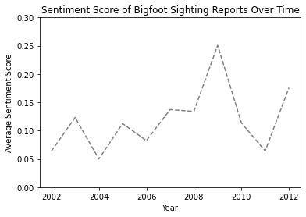

Figure 8

## Geospatial Analyses

A unique attribute of the BFRO dataset was that it included the latitude and longitude GPS coordinates of every reported Bigfoot sighting during the period of analysis. Given this granularity, these individual sightings were plotted on a map of the continental U.S. to visually determine where these sightings were concentrated across the country and within specific states.

Figure 9 concurrently depicts the exact locations of these Bigfoot sightings using black triangles and the average county-level binge drinking rate (for both genders) at the state-level using a color gradation scale. Given the latter, states with brighter and warmer colors had a higher average county-level binge drinking rate while those with darker and cooler colors had a relatively lower average county-level binge drinking rate. Of note, Maine, Alaska, and Hawaii were omitted from Figure 9 since they did not have any reported Bigfoot sightings in the period.

Average County-Level Binge Drinking Rate for Both Genders Combined

Figure 9

As can be inferred from Figure 9, there seemed to be a denser collection of reported Bigfoot sightings in states that had *lower* average county-level binge drinking rates. This can be seen when observing the concentration of sightings in the Pacific Norwest and in the South. Moreover, states with higher average county-level binge drinking rates (e.g., Wisconsin, Iowa, North and South Dakota, etc.) reported sparse sightings during this period. This preliminarily suggests that binge drinking may *not* be associated with Bigfoot sightings as previously hypothesized. The subsequent analyses explore this relationship further.

## Statistical Analyses

To test the aforementioned hypothesis that U.S. counties with higher rates of binge drinking among its residents would have *more* reported Bigfoot sightings, several statistical analyses were performed. First, two Pearson correlations were conducted to identify if a linear relationship existed between these two continuous variables and if so, to determine what the magnitude and direction of that relationship were. Figure 10 shows the results of these correlations via scatter plot graphs at the state-level and county-level respectively, where the former included 47 observations (all states except Hawaii, Alaska, and Maine that did not have any Bigfoot sightings during this period) while the latter had 825 observations (all unique counties that had at least one reported Bigfoot sighting during this period). These scatter plots in Figure 10 show total Bigfoot sightings against the average county-level binge drinking rates of females, males, and both, separately, as denoted by the colors red, blue, and purple, respectively.

Figure 10

In analyzing the results in Figure 10, both at the state- and county-levels, there seemed to be a negative correlation (i.e., relationship) between the number of Bigfoot sightings and the average county-level binge drinking rates—even when separated by gender. Namely, these variables move in the opposite direction (i.e., as the number Bigfoot sightings increased, the average county-level binge drinking rate abated and as the average county-level binge drinking rate increased, the number of Bigfoot sightings abated). The associated correlation coefficients are listed in Table 1 and as shown by these results, the magnitude (i.e., strength) of the correlation increased when analyzing the data at the county- versus the state-level. Based on the thresholds delineated in Cohen (1988), in comparing the state- to county-level coefficients, their strength remained weak (i.e., 0.10 – 0.30); yet, in referencing the thresholds denoted in Evans (1996), their strength did change from very weak (i.e., 0.00 – 0.19) to weak (i.e., 0.20 – 0.39).

**Table 1:** Pearson Correlation Coefficients at the State- and County-Levels

|  |  |  |
| --- | --- | --- |
| Category | State-Level | County-Level |
| Female | -0.1074 | -0.2141 |
| Males | -0.1741 | -0.3457 |
| Combined | -0.1479 | -0.3400 |
|  |  |  |

Of note, the above results suggest something contrary to the preliminary hypothesis of this project. The findings in Figure 10 and Table 1 posit counties with higher rates of binge drinking among its population have *fewer* reported Bigfoot sightings. This insinuates that localities whose residents practice relatively healthier drinking habits (i.e., less binge drinking), tend to have higher frequencies of Bigfoot sightings. To assess if this inverse relationship is statistically significant, an ordinary least squares (OLS) regression model was created. Equation (1) presents the functional specification that estimated whether county-level binge drinking rates impact the number of reported Bigfoot sightings. Specifically, *Per_Binge* (i.e., the dependent variable) was the county-level binge drinking rate for both genders combined, *Y* (i.e., the independent variable) was the number of Bigfoot sightings at the county-level, and ε was the error term.

Figure 11 shows a scatter plot graph of the 1,624 observations included in the sample and the resulting fitted regression line that was used to evaluate the relationship between the predictor variable (i.e., *Per_Binge*) and the response variable (i.e., *Y*). Also, the OLS regression results are delineated in Table 2.

Figure 11

**Table 2:** OLS Regression Results for the Relationship Between Bigfoot Sightings and Binge Drinking

|  |  |  |  |  |  |
| --- | --- | --- | --- | --- | --- |
| Variables | Coefficient | Standard Error | P-value | 95% Confidence Interval | |
| Per_Binge | -0.3580 | 0.025 | 0.000 | -0.406 | -0.31 |
| Constant | 16.1152 | 0.824 | 0.000 | 14.498 | 17.73 |

The results listed above indicate that the negative relationship between average county-level binge drinking rates and number of Bigfoot sightings is statistically significant at the 0.01 level. The associated interpretation of the resulting regression coefficient would be as follows: for every percentage point increase in the average county-level binge drinking rate (for both genders), the number of reported Bigfoot observations decreases by 0.36 sightings, holding all else constant. Namely, as the percentage of a county population who partakes in binge drinking increases, the number of Bigfoot observations reported in that county declines. Additional output results not listed in Table 2 include an R2 value of 0.115—meaning this model explained 11.5 percent of the change in the number of Bigfoot sightings—and an F-statistic value of 211.4 which was statistically significant at the 0.01 level. The latter suggests the model has predictive power (i.e., it fits the data better than a model with no independent variables). Of note, no additional control variables were included in the above OLS regression model due to both data and time constraints. Additional research could explore—with more comprehensive data—whether this relationship persists—and remains significant—after controlling for potentially confounding factors.

# Conclusion

The findings from this project demonstrate that there is an empirical relationship between county-level binge drinking rates and the number of Bigfoot sightings in the U.S. between 2002 and 2012. However, the results contradict the preliminary hypothesis that areas with higher binge drinking rates would be associated with increased reported sightings (due to the scientific evidence substantiating the harmful effects of heavy alcohol consumption on eyesight). Namely, the findings from this analysis indicate that Bigfoot sightings are associated with counties that have *lower* levels of binge drinking. This infers that not binge drinking but sobriety (i.e., less dangerous or frequent alcohol consumption) among a county’s population is associated with an increase in Bigfoot sightings. Thus, binge drinking is not a determinant. However, it is important to note that the binge drinking data used in this analysis represented the area in which these Bigfoot sightings *occurred*. They did not represent the binge drinking propensities of the reporter’s county of residence nor the inebriated state of the reporter at the moment of the sighting. Such data was not available. Hence, this research does not answer the question of whether individuals are sober or not when they do sight Bigfoot, but such empirical investigations should be pursued to better identify the determinants of Bigfoot—and potentially other cryptid—sightings in the U.S. and in other countries. Additional research should also explore whether other variables—such as marijuana use, poverty rates, education levels, political beliefs—are significant predictors of Bigfoot sightings. Doing this would help fill gaps in the existing literature as to what factors are driving this phenomenon.

# References

Ackermann, K. (2022, March 8). *Alcohol Induced Psychosis, Hallucinations, & Delusions*. Alcohol.org. Retrieved from <https://www.alcohol.org/comorbid/psychotic-disorder/>

Cohen, L. H. (Ed.). (1988). *Life events and psychological functioning: Theoretical and methodological issues* (Vol. 90). SAGE Publications, Incorporated.

Cohen, S. I., & Johnson, K. (1988). Psychosis from alcohol or drug abuse. *BMJ*, *297*(6658), 1270–1271. <https://doi.org/10.1136/bmj.297.6658.1270-c>

Dennett, M. (1989). Evidence for Bigfoot? An investigation of the Mill Creek'Sasquatch Prints.'. *Skeptical Inquirer*, *13*(3), 264-272. <https://cdn.centerforinquiry.org/wp-content/uploads/sites/29/1989/04/22165241/p50.pdf>

Evans, J. D. (1996). *Straightforward statistics for the behavioral sciences*. Thomson Brooks/Cole Publishing Co.

Fan, A. Z., Li, Y., Zhang, X., Klein, R., Mokdad, A. H., Saaddine, J. B., & Balluz, L. (2012). Alcohol consumption, drinking pattern, and self-reported visual impairment. *Ophthalmic Epidemiology*, *19*(1), 8–15. <https://doi.org/10.3109/09286586.2011.591037>

Khanna, C. (2021, February 10). *Text pre-processing: Stop words removal using different libraries*. Medium. <https://towardsdatascience.com/text-pre-processing-stop-words-removal-using-different-libraries-f20bac19929a#:~:text=Stop%20words%20are%20available%20in,focus%20to%20the%20important%20information>

Lozier, J. D., Aniello, P., & Hickerson, M. J. (2009). Predicting the distribution of sasquatch in Western North America: Anything goes with ecological niche modelling. *Journal of Biogeography*, *36*(9), 1623–1627. <https://doi.org/10.1111/j.1365-2699.2009.02152.x>

Maurage, P., Joassin, F., Speth, A., Modave, J., Philippot, P., & Campanella, S. (2012). Cerebral effects of binge drinking: Respective influences of global alcohol intake and consumption pattern. *Clinical Neurophysiology*, *123*(5), 892–901. <https://doi.org/10.1016/j.clinph.2011.09.018>

Meldrum, D. J. (2004). Midfoot flexibility, fossil footprints, and sasquatch steps: New perspectives on the evolution of bipedalism. *Journal of Scientific Exploration*, *18*(1), 65-79.

Meldrum, D.J. (2007). *Sasquatch: legend meets science*. Forge Books.

Mile, H. (2021, November 7). *Alcoholic eyes: Drinking alcohol & your eyesight: Heroes' mile veteran recovery center*. Heroes' Mile Veterans Recovery Center. Retrieved from <https://www.heroesmile.com/alcoholic-eyes-drinking-alcohol-your-eyesight/>

*Native American Legends: Sasquatch (Sesquac)*. Sasquatch (Sesquac), the Salishan Bigfoot. (n.d.). Retrieved from <http://www.native-languages.org/sasquatch.htm>

Neuharth, S. (2020, September 9). *Why have Bigfoot sightings decreased?* MeatEater Conservation. <https://www.themeateater.com/conservation/anthropology/why-have-bigfoot-sightings-decreased>

*Sasquatch*. The Canadian Encyclopedia. (n.d.). Retrieved from <https://www.thecanadianencyclopedia.ca/en/article/sasquatch>

Sinclair, K.L. (2017, May 19). Kristi Lane Sinclair on the Legend of the Sasquatch. SESQUI. Retrieved from <https://sesqui.ca/en/news/kristi-lane-sinclair-on-the-legend-of-the-sasquatch/>

Sykes, B. C., Mullis, R. A., Hagenmuller, C., Melton, T. W., & Sartori, M. (2014). Genetic analysis of hair samples attributed to Yeti, Bigfoot and other anomalous primates. *Proceedings of the Royal Society B: Biological Sciences*, *281*(1789), 20140161. <https://doi.org/10.1098/rspb.2014.0161>

1. Please reference the following websites to access to the original datasets provided by BFRO and the Global Health Data Exchange, respectively, used for this project: <https://data.world/timothyrenner/bfro-sightings-data> and <https://ghdx.healthdata.org/record/ihme-data/united-states-alcohol-use-prevalence-county-2002-2012>
2. “Binge drinking” for this project was defined as “the consumption of more than four drinks for women or five drinks for men on a single occasion at least once in the past 30 days” by the Global Health Data Exchange source.
3. Stop words are English words that do not add much meaning to a sentence as they only provide low-level information (e.g., prepositions, pronouns, conjunctions, etc.). Thus, they can be removed from text analysis without sacrificing sentence meaning. Please reference Khanna (2021) for additional information on this subject.
4. VADER is used to quantify how much negative and positive sentiment a section of text has and is used as a proxy for intensity of positive and negative emotion. For more information on this tool, please reference this website: <https://blog.quantinsti.com/vader-sentiment/>